**Code Smells**

Miguel Real 55677

Note: Before reviewing the code smells, note (to avoid repeating package directory) that they were located in: “src/main/java/org/jabref/logic/”, as this was the package I chose to scan for code smells.

1. **Duplicate Code**

Found in “bst/BstPreviewLayout.java”

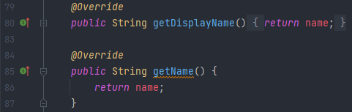

***Suggested Fix:*** Here we have two methods that do the exact same thing, and are therefore redundant. My suggestion is to simply remove one of them, more specifically getDisplayName(), which was added after getName() already existed and exists for the same purpose, to return the private global variable name.

1. **Inappropriate Intimacy & Duplicate Code**

Found in “importer/fetcher/ComplexSearchQuery.java”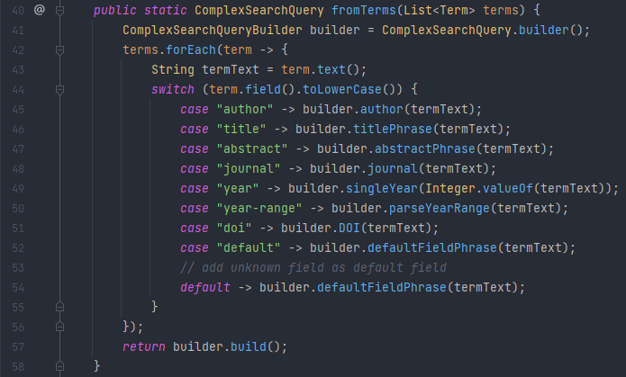

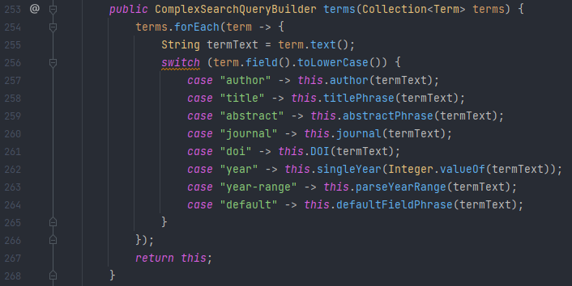

***Suggested Fix:*** The ComplexSearchQuery class has a fromTerms() method which simply creates a builder class and proceeds to utilize its methods exclusively to re-do the work that the terms() method (from ComplexSearchQueryBuilder, the aforementioned builder class) already does.

This displays not only Duplicate Code but also Inappropriate Intimacy, since the fromTerms() method of the ComplexSearchQuery class uses methods from the ComplexSearchQueryBuilder class almost exclusively. Our suggested fix involves deleting lines 42-56 of the method fromTerms(), and replacing its return statement with builder.terms(terms).build().

In this way we avoid the repeated code in fromTerms() and terms() and we solve the inappropriate intimacy displayed by fromTerms() regarding ComplexSearchQueryBuilder.

1. **Dead Code**

Found in “formatter/bibtexfields/CleanupUrlFormatter.java”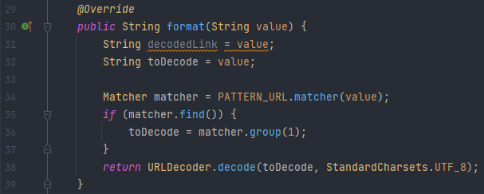

Found in “util/CoarseChangeFilter.java”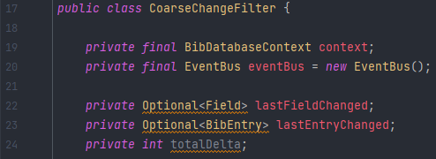

Found in “importer/fileformat/EndnoteImporter.java”

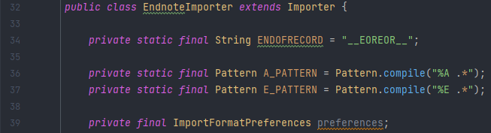

Found in “importer/fetcher/GvkFetcher.java”

***Suggested Fix:*** The first class has a method with an unused local variable decodedLink. The other classes have unused private global variables totalDelta, preferences and searchKeys. This may have been due to them being planned to have a use during development but the features were completed without needing them and they were either forgotten or left in the code in anticipation of future use.

My fix is obvious and simple, these variables should simply be deleted, as they are unused and do not affect their classes or the program/application as a whole.